Ex. No. 1 | Design A Website Using HTML5
Date of Exercise | 14.7.26
GitHub Host Link

Aim
To design and develop a simple yet structured Car Rental Service website using HTML5 by implementing semantic elements, headings, paragraphs, images, tables, lists, hyperlinks, comments, and basic CSS formatting to create an attractive and user-friendly webpage.
Description
This exercise is implemented using HTML5 and internal CSS to design a simple Car Rental Service webpage. The following technical concepts are used:
<!DOCTYPE html> | Declares the document as an HTML5 document.

<html> | Root element that contains the entire webpage.

<head> | Contains the title and style information of the webpage.

<title> | Displays the webpage title in the browser tab.

<style> | Applies CSS styles to the webpage.

<body> | Contains all the visible content of the webpage.

<div> | Divides the webpage into different sections.

<h1> | Displays the main heading of the webpage.

<h2> | Displays section headings.

<p> | Displays paragraphs of text.

<img> | Displays an image on the webpage.

<table> | Displays information in rows and columns.

<tr> | Creates rows in the table.

<th> | Displays table headings.

<td> | Displays table data.

<ul> | Creates an unordered (bulleted) list.

<ol> | Creates an ordered (numbered) list.

<li> | Represents items in a list.

<dl> | Creates a description list.

<dt> | Defines a term in the description list.

<dd> | Gives the description of the term.

<a> | Creates hyperlinks to other pages or sections.

background-color | Sets the background color of the webpage.

color | Changes the text color.

font-family | Changes the font style of the text.

border | Adds borders to the table.

border-collapse | Combines table borders into a single border.

padding | Adds space inside table cells.

width | Sets the width of the image.

<hr> | Inserts a horizontal line to separate sections.

Procedure:
- Open Visual Studio Code or any text editor.
- Create a new folder named CarRentalService.
- Inside the folder, create a new file named index.html.
- Save a car image in the same folder as car.jpg.
- Begin the HTML document with the <!DOCTYPE html> declaration.
- Add the required HTML5 tags such as <html>, <head>, <meta>, <title>, and <body>.
- Create different sections using <div> elements.
- Insert the main heading using <h1> and subheadings using <h2>.
- Add paragraphs describing the Car Rental Service using <p> tags.
- Insert a car image using the <img> tag.
- Create an ordered list, unordered list, and description list to display services and features.
- Create a table to display available cars and rental prices.
- Add different hyperlinks including external, internal, bookmark, email, phone, and clickable image links.
- Insert HTML comments before each section for better code readability.
- Apply background color and text color using internal CSS.
- Save the file.
- Open the file in a web browser or Live Server to view the output.
- Verify that all required HTML elements are displayed correctly.

Program
<!DOCTYPE html>
<html>
<head>
<title>Car Rental Service</title>
<style>
body {
background-color: #f0f8ff;
font-family: Arial;
margin: 20px;
}
h1 {
text-align: center;
color: darkblue;
}
.box {
width: 45%;
float: left;
border: 2px solid black;
padding: 15px;
margin: 10px;
background-color: white;
}
.clear {
clear: both;
}
.table {
width: 100%;
border-collapse: collapse;
}
.table, th, td {
border: 1px solid black;
padding: 8px;
text-align: center;
}
.img {
width: 100%;
height: 250px;
}
.a {
text-decoration: none;
}
</style>
</head>

<body>
<!-- Header Section -->
<h1 id="top">Car Rental Service</h1>
<p align="center">
Welcome to our Car Rental Service website. We provide affordable and comfortable rental cars for every journey.
</p>
<!-- About Us -->
<div class="box" id="about">
<h2>About Us</h2>
<p>
Our Car Rental Service offers clean, safe and comfortable cars for business trips,
family vacations and daily travel. Customer satisfaction is our priority.
</p>
</div>
<!-- Image Section -->
<div class="box">
<h2>Our Car</h2>
<img src="car.jpg" alt="Car Image">
</div>
<div class="clear"></div>
<!-- Services -->
<div class="box">
<h2>Our Services</h2>
<ul>
<li>Car Rental
<ul>
<li>Daily Rental</li>
<li>Weekly Rental</li>
<li>Monthly Rental</li>
</ul>
</li>
<li>Airport Pickup</li>
<li>Driver Service</li>
</ul>
</div>
<!-- Available Cars -->
<div class="box">
<h2>Available Cars</h2>
<ol>
<li>Sedan
<ol>
<li>Honda City</li>
<li>Swift Dzire</li>
</ol>
</li>
<li>SUV
<ol>
<li>Hyundai Creta</li>
<li>Mahindra XUV700</li>
</ol>
</li>
</ol>
</div>
<div class="clear"></div>
<!-- Features -->
<div class="box">
<h2>Car Features</h2>
<dl>
<dt><b>GPS</b></dt>
<dd>Navigation System</dd>
<dt><b>Air Conditioner</b></dt>
<dd>Comfortable Cooling</dd>
<dt><b>Music System</b></dt>
<dd>Entertainment While Travelling</dd>
</dl>
</div>
<!-- Rental Price -->
<div class="box">
<h2>Rental Price</h2>
<table>
<tr>
<th>Car</th>
<th>Type</th>
<th>Price/Day</th>
</tr>
<tr>
<td>Honda City</td>
<td>Sedan</td>
<td>₹1800</td>
</tr>
<tr>
<td>Hyundai Creta</td>
<td>SUV</td>
<td>₹2500</td>
</tr>
<tr>
<td>Mahindra XUV700</td>
<td>SUV</td>
<td>₹3000</td>
</tr>
</table>
</div>
<div class="clear"></div>
<!-- Hyperlinks -->
<div class="box">
<h2>Useful Links</h2>
<p>
<a href="https://www.google.com" target="_blank">
Visit Google
</a>
</p>
<p>
<a href="#about">
About Us
</a>
</p>
<p>
<a href="#top">
Back to Top
</a>
</p>
<p>
<a href="mailto:carrental@gmail.com">
Email Us
</a>
</p>
<p>
<a href="tel:+919876543210">
Call Us
</a>
</p>
<p>
<a href="https://www.google.com" target="_blank">
<img src="car.jpg" width="150" height="100" alt="Car">
</a>
</p>
</div>
<!-- Contact -->
<div class="box">
<h2>Contact Us</h2>
<p><b>Email:</b> carrental@gmail.com</p>
<p><b>Phone:</b> +91 9876543210</p>
<p><b>Address:</b> Coimbatore, Tamil Nadu</p>
</div>
<div class="clear"></div>
</body>
</html>
Output
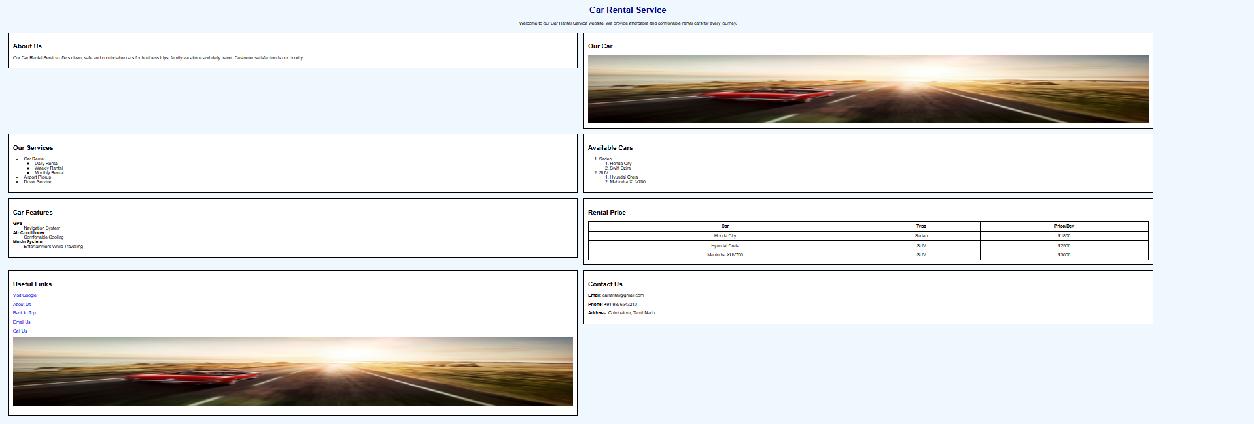

Result
The HTML5 Car Rental Service webpage was successfully designed and executed using HTML5 tags and basic CSS. The output was verified successfully.

